EdgeFusion v3

Quick Start Guide

OVERVIEW

EdgeFusion v3 - Data Ports

Ports | Description
AC Plug  (1x IEC 60320 C14) | Power input for EdgeFusion  (88 – 264 VAC)
Rear Panel Ethernet Ports (5x RJ45) | Ethernet ports - connect to WAN or LAN sources
FXS Ports  (8xRJ11) | FXS ports - connect analog phones /fax machines to the built-in HT818 using RJ11 telephone cable
ACU  (1x RJ45) | ACU port - used to connect to the external Antenna Control Unit
Front Panel RJ45  (1x RJ45) | Maintenance Port -Maintenance Laptop connection point to EdgeFusion, server setup to provide DHCP IP to Laptop

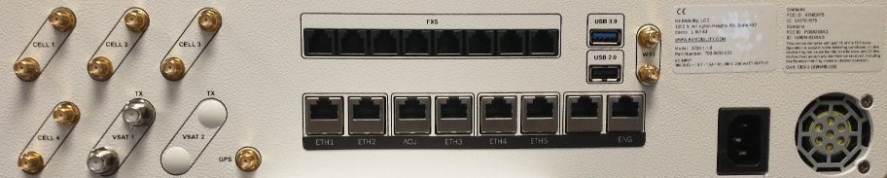

EdgeFusion v3 - RF Connections
RF Connector | Description
GPS  (1x SMA-F) | GPS Rx Antenna, the power provided via coax, and one LTE modem - provides positioning information
Wi-Fi  (2x SMA-F) | 802.11 ac/a/b/g/n 2x2 MIMO, 1166 Mbps - provides Marina Wi-Fi access
Cell 1-4  (2x SMA-F per LTE modem) | 4x Sierra Wireless CAT12 LTE Modems (EM7565) 600/150Mbps each – provides cellular 1, 2, 3 and 4 ports of access
VSAT 1  (2x F-Type Female, 75 Ohm) | 2x iQ200 modems - provides VSAT 1 port access

Connecting the EdgeFusion v3
- After installing the unit in the rack, connect an internet connection to the ‘ETH1’ port.
- Connect the ethernet port from the ACU to the ethernet port labeled ‘ACU’ on the rear of the unit.
- Connect the Tx and Rx VSAT coax cables from the ACU to the Tx and Rx F-Type connectors labeled ‘VSAT 1’.
- If you are using the internal LTE radios, connect the antenna cables to the SMA connectors ‘Cell 1’ through ‘Cell 4’.
- Connect any analog phones to the OneBox using an RJ-11 cabled in the ports labeled ‘FXS1’ through ‘FXS8’.
- Connect the GPS antenna to the ‘GPS’ SMA connector on the back of the unit. The GPS port of the OneBox provides DC power on the RF line for the antenna.
- If you are using the onboard Wi-Fi, connect two Wi-Fi antennas to the female ‘WiFi’ SMA connectors on the back of the unit.
- Connect the AC power cord
- Finally, connect ‘ETH 4’ port to either your LAN network or directly to your laptop.

Connect to Edge Web Portal for Configuration and Management
- Connect the Laptop Ethernet interface to EdgeFusion v3 ‘ETH 4’ port and configure the laptop interface for DHCP.
- Laptop IP address should be assigned from the 192.168.231.0/24 network space; with the Default GW of 192.168.231.1, and DNS of 8.8.8.8.
- Open Web Browser on Laptop; enter the URL: http://192.168.231.1 and hit enter.
- Portal login appears, utilize the K4 provided username/password, or with a new system utilize the temporary login of: edge/edge.
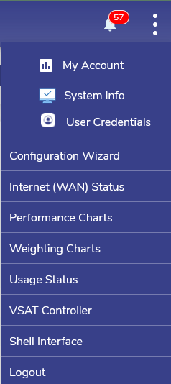
- Edge Portal Dashboard will appear on the “Configuration Wizard” home page. Menu “3 dots” Icon Upper Right.
  - Internet link status - “Internet (WAN) Status”.
  - LTE status - “LTE Controller”.
  - Internet Performance - “Performance Charts”
  - Device Usage – “Usage Status”
  - Update Configuration - “Configuration Wizard”

